"Обновление ClamAV" (https://jira.tcsbank.ru/browse/IN-1183) [Петрова Юлия] [назначил Александров Алексей].
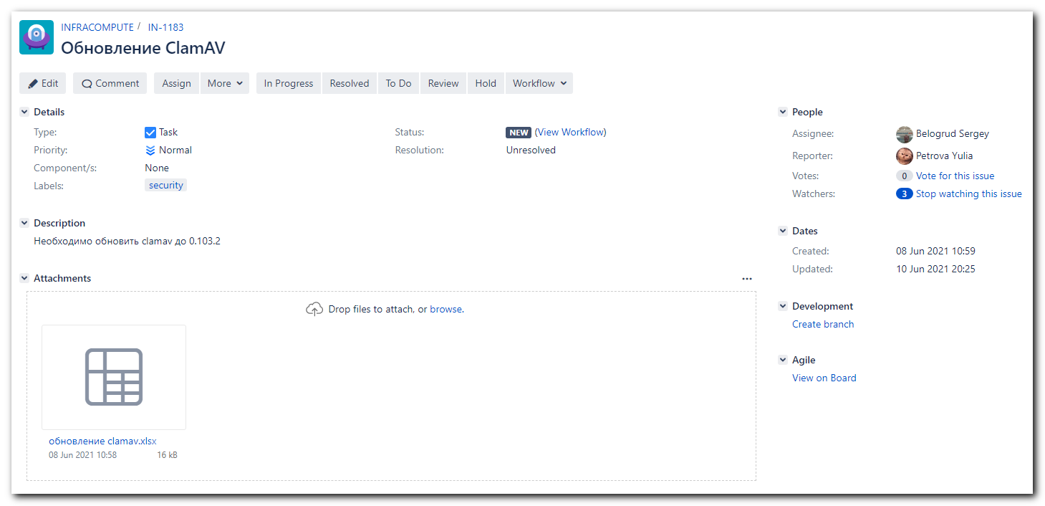
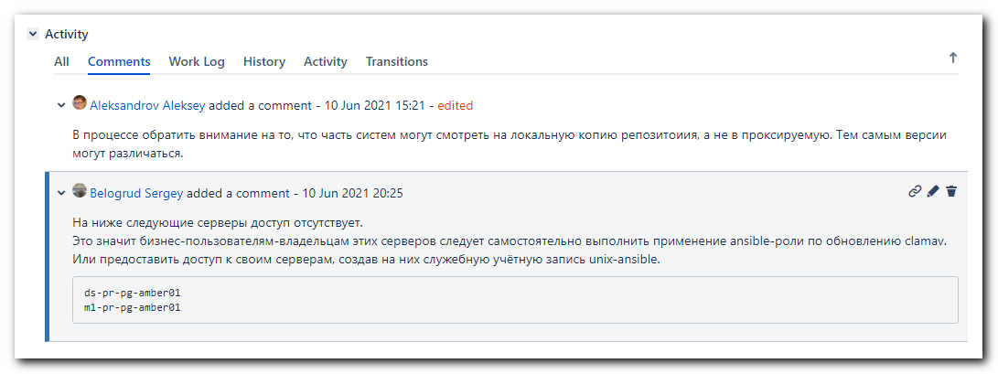

#
# For DB servers.
#
[support@nb2339]# export ANSIBLE_CONFIG=ansible.cfg ; logfile="$(date +%Y%m%d-%H%M).playbook.log.txt" ; ansible-playbook 20200916-1233.clamav.yml -i list_of_hosts --become --extra-vars "ansible_user=unix-ansible ansible_password=$(pass common/linux-unix-ansible) ansible_sudo_pass=$(pass common/linux-unix-ansible) ansible_ssh_common_args='-oStrictHostKeyChecking=no -oPubkeyAuthentication=no -oUserKnownHostsFile=/dev/null'" --extra-vars '{"clamscan_timeout": "timeout 2h", "clamscan_weekday": "0", "clamscan_hour": "2", "clamscan_minute": "00","clamscan_extra_exclude":["/opt","^/data","^/oramnt","^/mnt"]}' -f 50 | tee -a ./output/${logfile}

#
# For all other servers.
#
[support@nb2339]# export ANSIBLE_CONFIG=ansible.cfg ; logfile="$(date +%Y%m%d-%H%M).playbook.log.txt" ; ansible-playbook 20200916-1233.clamav.yml -i list_of_hosts --become --extra-vars "ansible_user=unix-ansible ansible_password=$(pass common/linux-unix-ansible) ansible_sudo_pass=$(pass common/linux-unix-ansible) ansible_ssh_common_args='-oStrictHostKeyChecking=no -oPubkeyAuthentication=no -oUserKnownHostsFile=/dev/null'" -f 100 | tee -a ./output/${logfile}

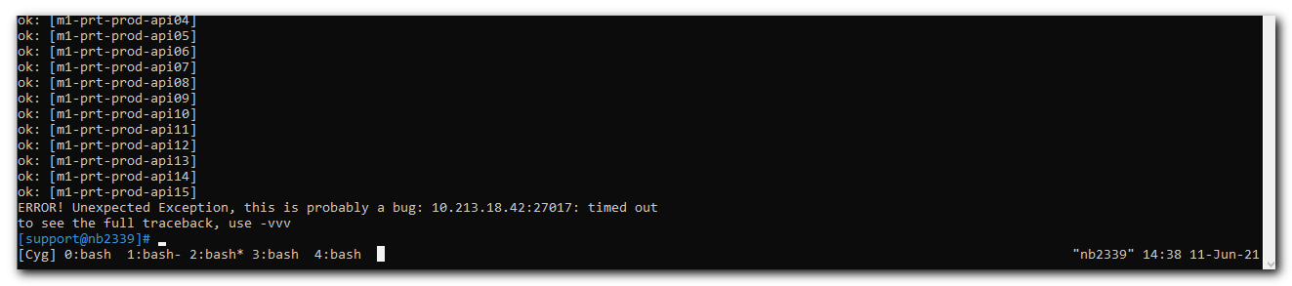

...
TASK [ans_int/clamav : conevrt list to var freshclam_run_options] ***************************************************************************************************************
Friday 11 June 2021 14:35:19 +0300 (0:01:02.399) 1:02:14.602 ***********
ok: [ds-afd-balancer02]
ok: [ds-net-elb01]
ok: [ds-net-ilb01]
...
ok: [m1-prt-prod-api13]
ok: [m1-prt-prod-api14]
ok: [m1-prt-prod-api15]
ERROR! Unexpected Exception, this is probably a bug: 10.213.18.42:27017: timed out
to see the full traceback, use -vvv
[support@nb2339]#

...
TASK [Gathering Facts] ****************************************************************************************************************************************
Friday 11 June 2021 14:41:43 +0300 (0:00:00.457) 0:00:00.457 ***********
ok: [ds-net-elb01]
ok: [ds-afd-balancer02]
...
ok: [m1-prt-prod-api14]
ok: [m1-prt-prod-api15]
ok: [m1-prt-prod-api16]
fatal: [m1-prt-prod-api21]: UNREACHABLE! => {"changed": false, "msg": "Failed to connect to the host via ssh: ssh: Could not resolve hostname m1-prt-prod-api21: Temporary failure in name resolution", "unreachable": true}
ok: [m1-prt-prod-api17]
fatal: [m1-prt-prod-api18]: FAILED! => {"msg": "Timeout (12s) waiting for privilege escalation prompt: "}
ok: [m1-prt-prod-api19]
ok: [m1-prt-prod-api22]
ERROR! Unexpected Exception, this is probably a bug: No replica set members match selector "Primary()", Timeout: 30s, Topology Description: <TopologyDescription id: 60c34d1252b394ab35f90132, topology_type: ReplicaSetNoPrimary, servers: [<ServerDescription ('10.212.18.39', 27017) server_type: RSSecondary, rtt: 0.00829669999802718>, <ServerDescription ('10.213.18.42', 27017) server_type: Unknown, rtt: None>, <ServerDescription ('10.213.18.43', 27017) server_type: RSSecondary, rtt: 0.008991700000478886>]>
to see the full traceback, use -vvv
[support@nb2339]#

[s.belogrud@nb2339]# host 10.213.18.42
42.18.213.10.in-addr.arpa domain name pointer ds-ansible-cache01p.tcsbank.ru
[s.belogrud@nb2339]#

#
# It looks like the errors came from these lines in ansible.cfg.
[s.belogrud@nb2339]# cat /drives/c/data/work/ansible/stash.tcsbank.ru/ansible.cfg
[defaults]
force_valid_group_names = ignore
deprecation_warnings = False
host_key_checking = False
stdout_callback = default
hash_behaviour = merge

# retry_files_enabled = False
retry_files_enabled = True
retry_files_save_path = ./retry

callback_whitelist = profile_tasks
# ANSIBLE_FORCE_COLOR = yes

fact_caching_connection = "mongodb://ds-ansible-cache01p.tcsbank.ru:27017,ds-ansible-cache02p.tcsbank.ru:27017,m1-ansible-cache01p.tcsbank.ru:27017/?replicaSet=ansible-cache"
fact_caching=mongodb
fact_caching_timeout=2678400
fact_caching_prefix=ansible_facts_

# https://docs.ansible.com/ansible/2.4/intro_configuration.html#pipelining
pipelining = True
[s.belogrud@nb2339]#

# 20210615

[13:14:09 root@m1-db22-dr ~]# yum search clamav
Loaded plugins: langpacks, product-id, search-disabled-repos, subscription-manager
================================================================== N/S matched: clamav ==================================================================
clamav-filesystem.noarch : Filesystem structure for clamav
clamav-unofficial-sigs.noarch : Scripts to download unofficial clamav signatures
clamav.x86_64 : End-user tools for the Clam Antivirus scanner
clamav-data.noarch : Virus signature data for the Clam Antivirus scanner
clamav-devel.x86_64 : Header files and libraries for the Clam Antivirus scanner
clamav-lib.x86_64 : Dynamic libraries for the Clam Antivirus scanner
clamav-milter.x86_64 : Milter module for the Clam Antivirus scanner
clamav-update.x86_64 : Auto-updater for the Clam Antivirus scanner data-files

Name and summary matches only, use "search all" for everything.
[13:14:17 root@m1-db22-dr ~]# yum list available clamav
Loaded plugins: langpacks, product-id, search-disabled-repos, subscription-manager
Available Packages
clamav.x86_64 0.103.2-1.el7 tcs-epel
[13:14:48 root@m1-db22-dr ~]# yum list --showduplicates clamav
Loaded plugins: langpacks, product-id, search-disabled-repos, subscription-manager
Installed Packages
clamav.x86_64 0.103.1-3.el7 @repo-linux.tcsbank.ru_epel_7Server_x86_64_
Available Packages
clamav.x86_64 0.103.2-1.el7 tcs-epel
[13:16:38 root@m1-db22-dr ~]# yum install clamav
Loaded plugins: langpacks, product-id, search-disabled-repos, subscription-manager
Resolving Dependencies
--> Running transaction check
---> Package clamav.x86_64 0:0.103.1-3.el7 will be updated
---> Package clamav.x86_64 0:0.103.2-1.el7 will be an update
--> Processing Dependency: clamav-filesystem = 0.103.2-1.el7 for package: clamav-0.103.2-1.el7.x86_64
--> Processing Dependency: clamav-lib = 0.103.2-1.el7 for package: clamav-0.103.2-1.el7.x86_64
--> Running transaction check
---> Package clamav-filesystem.noarch 0:0.103.1-3.el7 will be updated
--> Processing Dependency: clamav-filesystem = 0.103.1-3.el7 for package: clamd-0.103.1-3.el7.x86_64
--> Processing Dependency: clamav-filesystem = 0.103.1-3.el7 for package: clamav-data-0.103.1-3.el7.noarch
--> Processing Dependency: clamav-filesystem = 0.103.1-3.el7 for package: clamav-update-0.103.1-3.el7.x86_64
---> Package clamav-filesystem.noarch 0:0.103.2-1.el7 will be an update
---> Package clamav-lib.x86_64 0:0.103.1-3.el7 will be updated
---> Package clamav-lib.x86_64 0:0.103.2-1.el7 will be an update
--> Running transaction check
---> Package clamav-data.noarch 0:0.103.1-3.el7 will be updated
---> Package clamav-data.noarch 0:0.103.2-1.el7 will be an update
---> Package clamav-update.x86_64 0:0.103.1-3.el7 will be updated
---> Package clamav-update.x86_64 0:0.103.2-1.el7 will be an update
---> Package clamd.x86_64 0:0.103.1-3.el7 will be updated
---> Package clamd.x86_64 0:0.103.2-1.el7 will be an update
--> Finished Dependency Resolution

Dependencies Resolved

=========================================================================================================================================================
Package Arch Version Repository Size
=========================================================================================================================================================
Updating:
clamav x86_64 0.103.2-1.el7 tcs-epel 431 k
Updating for dependencies:
clamav-data noarch 0.103.2-1.el7 tcs-epel 213 M
clamav-filesystem noarch 0.103.2-1.el7 tcs-epel 40 k
clamav-lib x86_64 0.103.2-1.el7 tcs-epel 830 k
clamav-update x86_64 0.103.2-1.el7 tcs-epel 123 k
clamd x86_64 0.103.2-1.el7 tcs-epel 118 k

Transaction Summary
=========================================================================================================================================================
Upgrade 1 Package (+5 Dependent packages)

Total download size: 215 M
Is this ok [y/d/N]: N
Exiting on user command
Your transaction was saved, rerun it with:
yum load-transaction /tmp/yum_save_tx.2021-06-15.13-17.P9kggw.yumtx
[13:17:36 root@m1-db22-dr ~]#

#
# I changed variable.
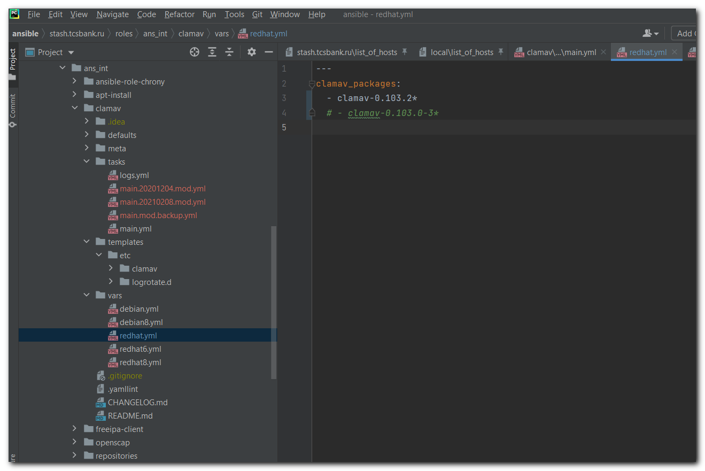

# After applying clamav role with changed variable.
[13:26:37 root@m1-db22-dr ~]# yum list --showduplicates clamav
Loaded plugins: langpacks, product-id, search-disabled-repos, subscription-manager
Installed Packages
clamav.x86_64 0.103.2-1.el7 @tcs-epel
Available Packages
clamav.x86_64 0.103.2-1.el7 tcs-epel
[13:26:52 root@m1-db22-dr ~]#

#
# 20210615
# I reapplyed ansible role to all servers.

# And some notes from Pavel Selin.
